|  |  |  |  |  |  |
| --- | --- | --- | --- | --- | --- |
|  |  | | | | |
|  | |  | | | |
| Project: | | University Bazaar System (UBS) | | | |
| Team No.: | | 11 | | | |
| Class: | | CSE 3310; Spring 2021 | | | |
| Module: | | User Manual | | | |
| Deliverable: | | User Manual Document | | | |
| Version: | | | [1.0] | Date: | [05/02/2021] |

Team members are:

Michelle Nguyen

Jackelyn Macias-Brijil

Aditya Mishra

Revision History

| Version number | Date | Originator | Reason for change | High level description of changes |
| --- | --- | --- | --- | --- |
| 1.0 | 05/02 | Team 11 | Initial draft |  |
| 2.0 | 05/04 | Team 11 | User Manual |  |
|  |  |  |  |  |
|  |  |  |  |  |

TABLE OF CONTENTS

1. Screenshots: “UBS Start Page” 3

2. Screenshots: “Registration” 4

3. Screenshots: “Login” 6

4. Screenshots: “UBS Homepage” 8

5. Screenshots: “Search” 9

6. Screenshots: “Clubs” 11

7. Screenshots: “Sales” 14

8. Screenshots: “Communication” 15

9. Screenshots: “Exchange” 16

10. Screenshots: “Payments” 19

# 1. Screenshots: “UBS Start Page”

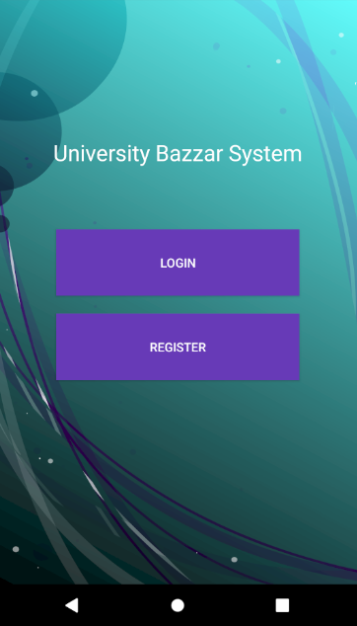

# 2. Screenshots: “Registration”

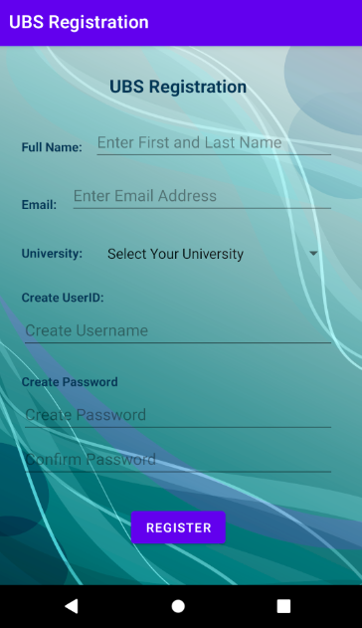

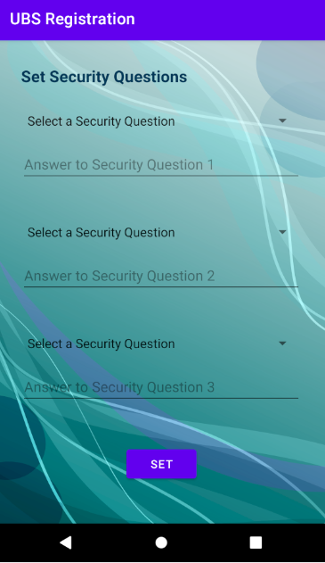

# 3. Screenshots: “Login”

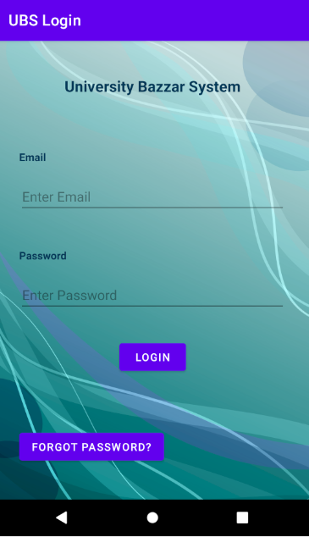

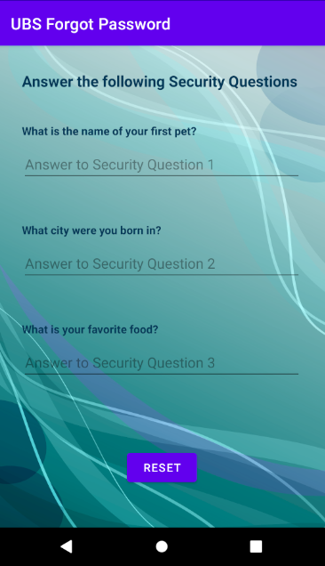

# 4. Screenshots: “UBS Homepage”

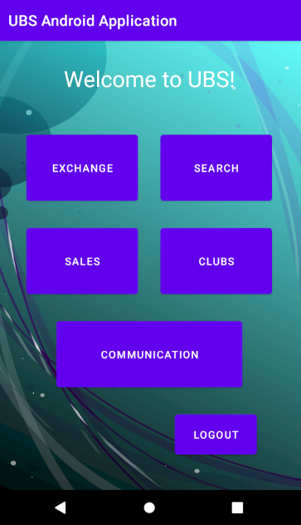

# 5. Screenshots: “Search”

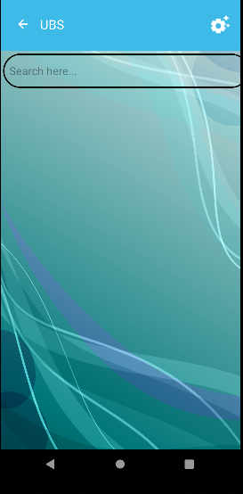

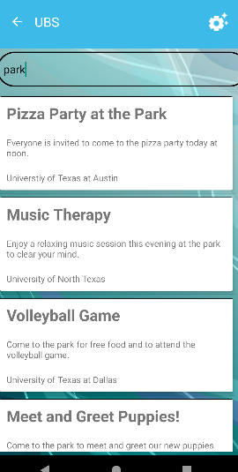

# 6. Screenshots: “Clubs”

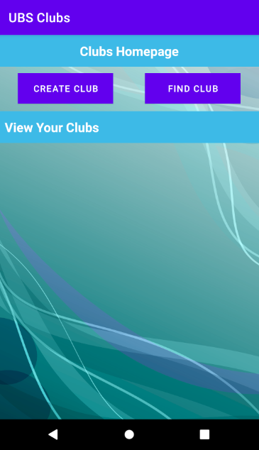

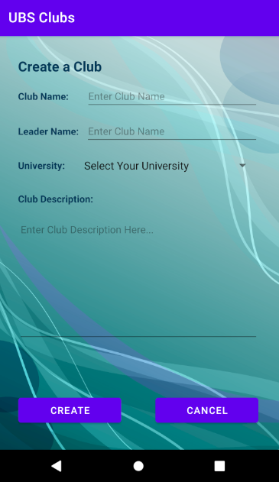

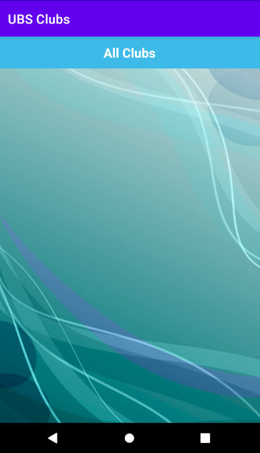

# 7. Screenshots: “Sales”

No Screenshot because Sales hasn’t been implemented into the app.

# 8. Screenshots: “Communication”

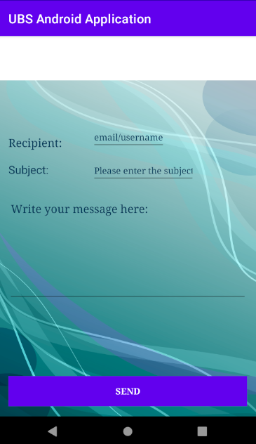

# 9. Screenshots: “Exchange”

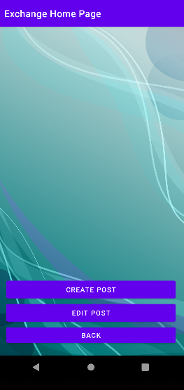

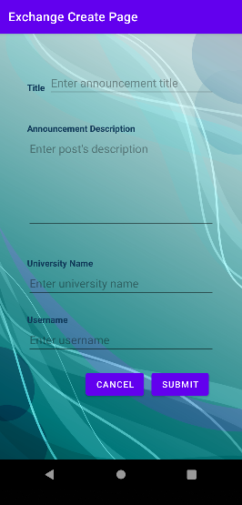

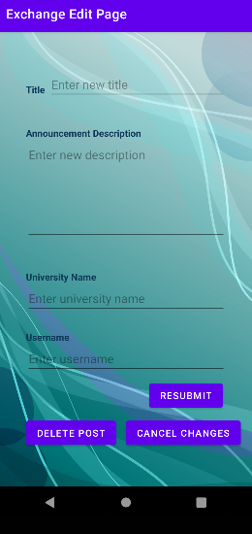

# 10. Screenshots: “Payments”

No Screenshot because Payments hasn’t been implemented into the app.